Due Date:

At the end of your scheduled lab period. (**Show it to your lab instructor)**

Marks: 10

Purpose:

To create, implement, and test a backup system.

## Requirements:

* Windows 10

Choose **any two storage drive** (external, online):

* An external hard drive
* A USB thumb drive
* Online (one drive, Gmail, Hotmail…)

## Introduction:

Companies and people are very dependent on data. Whereas a person cannot survive without air, water, and food; businesses and people cannot survive without data. Sixty-eight percent of companies do not have a reliable data backup and recovery plan in place.

In an academic setting such as the College, eighty-eight percent of students do not have proper data backup or recovery plan. As a result, many students end up failing a course(s) or their entire term due to a major data loss.

## Figuring Out a Backup Plan

It takes time to create and implement a backup and recovery plan. You'll need to figure out what data needs to be backed up, how often the data should be backed up, and more. To help you create a plan, consider the following questions:

**How important is the data on your systems?** The importance of data can go a long way in helping you determine if you need to back it up—as well as when and how it should be backed up. For critical data, such as a database, you'll want to have redundant backup sets that extend back for several backup periods. For less important data, such as daily user files, you won't need such an elaborate backup plan, but you'll need to back up the data regularly and ensure that the data can be recovered easily

**What type of information does the data contain?** Data that doesn't seem important to you now may be very important in the future.

**How often does the data change?** The frequency of change can affect your decision on how often the data should be backed up. For example, data that changes daily should be backed up daily.

**How quickly do you need to recover the data?** Time is an important factor in creating a backup plan. For critical systems, you may need to get back online swiftly. To do this, you may need to alter your backup plan.

**Do you have the equipment to perform backups?** You must have backup hardware to perform backups. To perform timely backups, you may need several backup devices and several sets of backup media. Backup hardware includes tape drives, optical drives, and removable disk drives. Generally, tape drives are less expensive but slower than other types of drives.

**Who will be responsible for the backup and recovery plan?** Ideally, someone should be a primary contact for the organization's backup and recovery plan. This person may also be responsible for performing the actual backup and recovery of data.

**What is the best time to schedule backups?** Scheduling backups when system use is as low as possible will speed the backup process. However, you can't always schedule backups for off-peak hours. So you'll need to carefully plan when key system data is backed up.

**Do you need to store backups off-site?** Storing copies of backup tapes off-site is essential to recovering your systems in the case of a natural disaster. In your off-site storage location, you may want to include copies of the software you may need to install to reestablish operational systems.

There are many different methods to create reliable data backups, each system has its’ own distinct advantages and disadvantages. This lab outlines **two** different ways of performing data backups using Windows 10. You can **either method** or if you already have a data backup plan already in place, you can continue to use it.

## Procedure:

## Method 1: Using Windows 7 Backup & Restore in Windows 10 to create a Full Backup

Before using this method, ensure that you have a partition available on a hard drive or an external hard drive or a USB thumb drive plugged into the computer.

1. Access the **Control Panel** by right-clicking on the **Start** button in the bottom left-hand corner and selecting Control Panel from the menu. You may also type "Control Panel" into the search box and select Control Panel from the results.

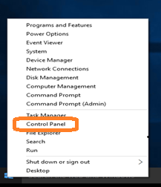

Figure 1. Selecting the Control Panel

1. In the control panel, click ***Backup and Restore (Windows*** *7)*.

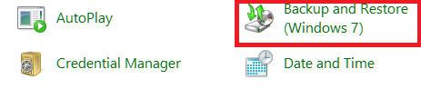

Figure 2 Choosing Backup and Restore

1. Click ***Set up backup*** and wait for Windows Backup to start.

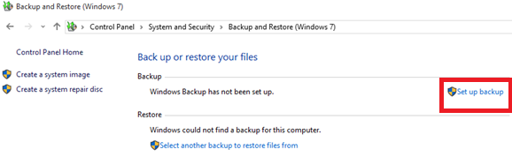

Figure 3. Set up Backup

1. Select a destination for your backups.

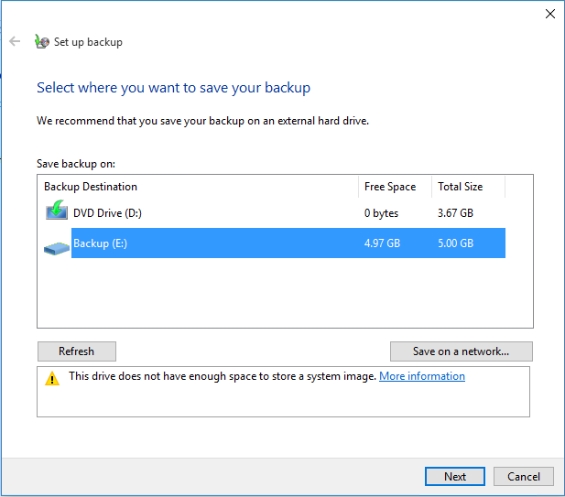

Figure 4. Select a destination for your backups

1. Next, select the ***Let Me*** *Choose* radio button so that you can specify exactly what directories or files you want to backup.
2. Check any folder that you would like to backup such as your school projects, work files, resume, tax files, etc.…

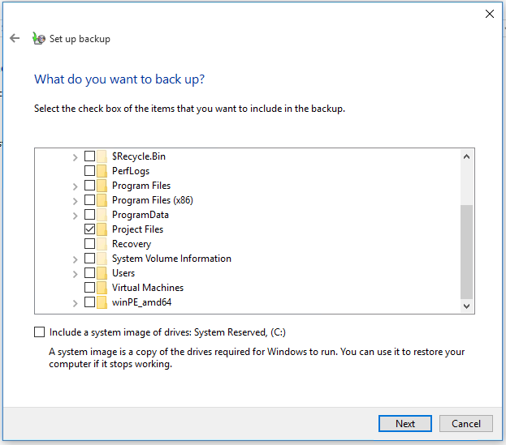

Figure 5. Choosing which folders to backup.

1. Create a schedule for when you wish your backups to take place. Make sure that the backup schedule occurs when the PC will be turned on and when the destination drive will be connected.
2. Select Change a schedule.

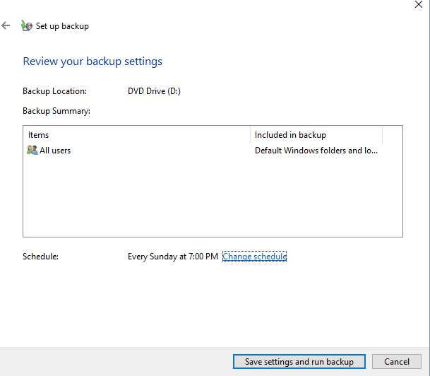

Figure 6. Changing the Backup Schedule

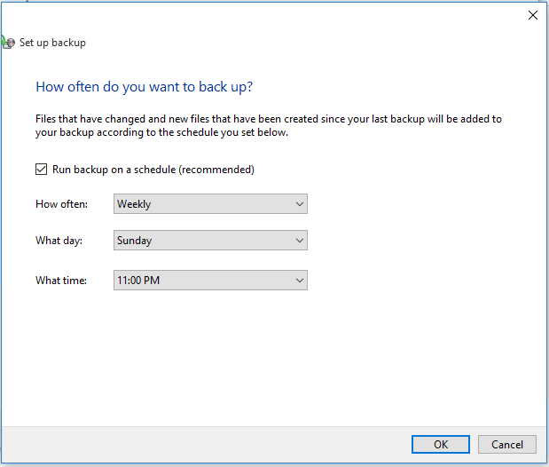

Figure 7. Setting up the Backup Schedule

1. The first full backup will occur when you have completed all the steps. This process may take some time so ensure that you can wait until the process is completed before having to move your laptop.

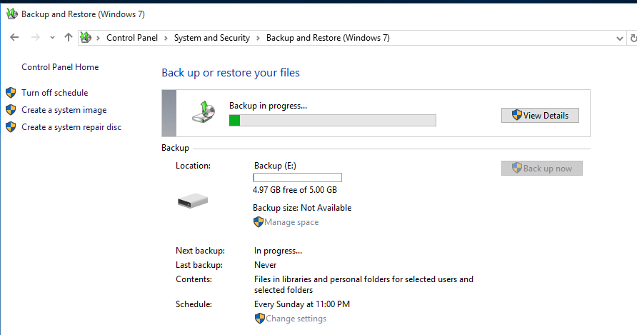

Figure 8. First Full Back up in Progress

When the backup has been completed successfully, you should practice a File Restore so you know that you can restore your files should you ever have to.

1. Restore a copy of your backup to a folder called **Restored Files** on a hard drive. This does not have to be done on your source disk. Ensure that you restore your backup to the **Restored Files** directory so that you do not accidentally overwrite any files in your source directory.

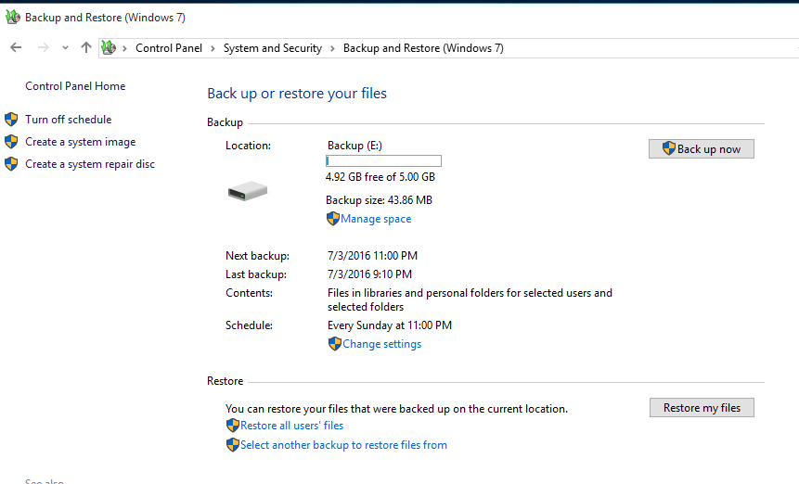

Figure 9. Restoring Files

## Method Two: Using File History

Before you start using **File History** to back up your files, you first need to select where your backups will be saved to. You can select an externally connected drive, such as a **USB drive**, or to an **external hard drive**, or you can save to **a drive** on a **network**.

**File History**, by default, only backs up files that are in the **Documents, Music, Pictures**, **Videos**, and **Desktop** folders and the **OneDrive** files available offline on your PC. If you have files or folders elsewhere that you want backed up, you must add them.

If you're going to use a new external drive, connect it to your PC. If you see a notification asking if you want to configure the drive for File History, select it, and then turn on File History on the screen the appears.

## Accessing File History

1. Access the Settings Panel by left-clicking on the Start button in the bottom left-hand corner and selecting Control Panel from the menu. You may also type **"Settings"** into the search box and select **Settings Panel** from the results.
2. Click on the **Update and Security** Icon

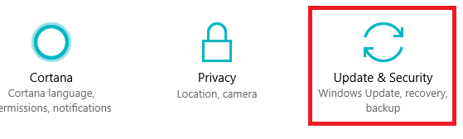

Figure 10. Update & Security

1. Select **Backup** from the menu, located on the left-hand side of the screen.
2. From the **Backup** screen chose the more options link

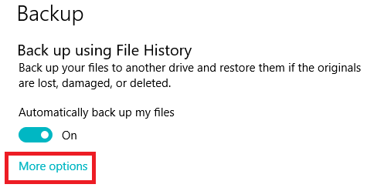

Figure 11. Selecting more options from the Backup menu

## File History: Adding Folders

1. To add other folders to File History, click on + icon in the Back up these folder section.

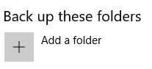

Figure 12. Add folders to File History

1. Choose the folder you wish to add, then click on the **Choose this folder** button. If there are other folders that you wish to include, repeat steps one and two until you have selected all the folders you want to add to File History.

If you accidently add a folder, you can remove the folder by left-clicking on the folder you wish to remove and clicking on the remove button as seen in Figure 13.

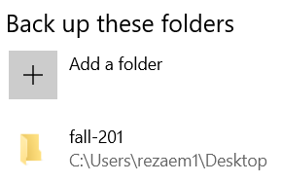

Figure 13. Removing a folder from file History.

## Excluding a folder from File History

If there are folders that you wish to exclude from File History, scroll down until you see Exclude these folders

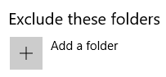

Figure 14. Excluding Folders from File History.

1. To exclude folders from being backed up in File History, click **on + icon**.
2. Choose the folder you wish to exclude, then click on the **Choose this folder** button.

If there are other folders that you wish to exclude, repeat steps three and four until you have selected all the folders you want to exclude from File History.

If you make a mistake, simply left-click on the folder that you don’t wish to exclude and click on the remove button.

## Choose a date and time to back up in File History:

By default, File History will back up files **every hour** and keep them forever which may not be ideal for a student given their school schedule and limited funds available for backup devices.

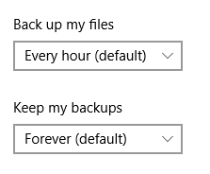

Figure 15. Default back up schedule in File History.

1. To change the frequency of how often File History runs, click on the arrow under the Back up my files and select a more appropriate option. Remember to schedule a time when the system use is as low as possible to speed the backup process.
2. To change the frequency of how long to keep the data backup, click on the arrow under the **Keep my backups** and select a more appropriate option. **Six months** may be an appropriate option if you are backing up data to a **USB thumb** drive, it really depends on the size of your drive and how long you want to keep the data.

Once you have finished with your selections, click on the **Back up now** button. This process may take some time so ensure that you can wait until the process is completed before having to move your laptop.

## Lab Questions:

Create a Microsoft Word document, answer the following questions using your own words. (Red)

1. What type of Backup strategy did you implement? Full, Differential, Incremental, one off? A combination of all of them?

I used incremental. So everytime I add information it gets saved.

2. When are you going to perform your data backups? Day and time is acceptable answer. Anytime my computer is online. Thursdays at 2:00

3. Why would you want to practice restoring your data from a backup? Just in case you lose your data and you want to retrieve it you can use the restore feature.

1. If no data loss has occurred; why might you want to restore a copy of your backup?
2. Virus or corruption in the hardrive. Extra safety.

## Deliverables

When you have completed the lab, **show it your lab instructor**. Ensure that your answers are accurate and in your own words. Do not copy answers from your friend(s). Ensure that your answer file is in Microsoft Word.docx format.

## CST8101 Lab 3 Marking Guide

|  |  |
| --- | --- |
| **5 Marks**  **3 Marks** | Answers to questions are well thought out.  Multiple places(local computer, memory stick, on line) |
| **2 Mark** | Lab 9 was submitted on time and in the correct format |
| **10 Marks** | Total |